**Pune Institute of Computer Engineering Dhankawadi, Pune**

**DEPARTMENT OF COMPUTER ENGINEERING**

**ACADEMIC YEAR 2022 - 23**

Mini Project Report

Topic: CANTEEN MANAGEMENT SYSTEM

SUBMITTED BY:

Name : Shriwatsal Patil

Roll No. : 32448 Class: TE-8

Name : Nikhil Awatade

Roll No. : 31206 Class: TE-2

**Under the guidance of Prof. Vijendra Gaikwad**

**Contents**

1. TITLE 3
2. PROBLEM DEFINITION 3
3. LEARNING OBJECTIVES 3
4. LEARNING OUTCOMES 3
5. ABSTRACT 4
6. S/W & H/W REQUIREMENTS 5
7. BLOCK DIAGRAM 5
8. USER ROLES & THEIR DESCRIPTION7 6
9. FUNCTIONAL DESCRIPTION 6
10. ER DIAGRAM  7

11 SCHEMA

12 TEST CASES

13 OUTPUT SCREENSHOTS

14 CONCLUSION 12

**Title:** CANTEEN MANAGEMENT SYSTEM

**Problem Definition:**

A website for PICT Canteen for efficient management of Menu and orders with personal database for their respective users.

**Learning Objectives:**

1. Connectivity between SQL database and frontend UI using PHP and HTML, CSS.
2. Implementation of CRUD operations on real life database.
3. Collecting the order details and processing it.
4. Keeping Records of Orders in the canteen.

**Learning Outcomes:**

1. Connectivity between SQL database and front-end UI using PHP and HTML, CSS.
2. Implementation of CRUD operations on real life database.
3. Collecting the order details and processing it.
4. Keeping Records of Orders in the canteen.

**ABSTRACT**

The purpose of the project entitled as “CANTEEN MANAGEMENT SYSTEM” is to computerize the Front Office Management of PICT CANTEEN to develop software which is user friendly simple, fast, and cost – effective. It deals with the collection of food orders, adding the items to the cart, live updating the menu using Admin login, etc. Traditionally, it was done manually. The main function of the system is register and store user details and Admin details and retrieve these details as and when required, and also to manipulate these details meaningfully System input contains cart orders, updates, while system output is to get these details on to the screen. The Canteen Management System can be entered using a username and password. It is accessible also by an administrator. The Admin and the complete control over updating the menu. The data can be retrieved easily. The data are well protected for personal use and makes the data processing very fast.

**Hardware Requirements :**

Processor : Intel Dual Core ,I3

Ram : 1 Gb

Hard Disk : 80 Gb

**Software Requirements :**

Operating System : Windows 7/ XP/8

Front End : HTML, CSS, Java Script.

Server Side Script : PHP

Database : MySQL

**Block Diagram:**

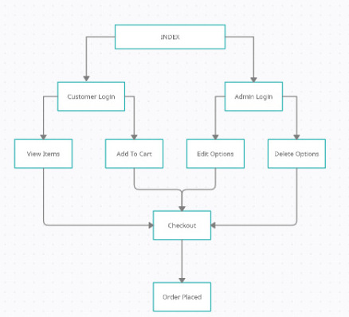

**User Roles And Description:**

**Admin:**

* Separate Admin Login
* Admin Dashboard.
* Customers Lists maintained.
* View, Edit, Delete Customer Details.
* Add New Customer Manually.
* Maintain Shop List and Menu List.
* View, Edit, Delete Menu Options.
* Edit the Availability and Pre-Order options.

**Customer:**

* Separate login/sign-up option with Forgot Password features.
* Home page displays Menu which includes Breakfast, Lunch and Dinner.
* The Open Hours are displayed and the Availability.
* Can add any item available to cart.
* User can mention any other Additional Requests.
* User can select their own Pick-up Details and Checkout.
* The order will be placed with a unique Order Number which is to be provided.
* User can check the Order details form Order History Page.

**Management:**

* Can view the Orders placed and act upon them accordingly.

**Functional Descriptions:**

* { customer_order } 🡪 { order_id }
* { customer_order_history } 🡪 { customer_id }
* { shopalltime_revenue } 🡪 { shop_id }
* { shop_menu_revenue } **->** { shop_id }
* { userID } 🡪 { username }
* { userID, username } 🡪 { address }

**ER** **Diagram**:

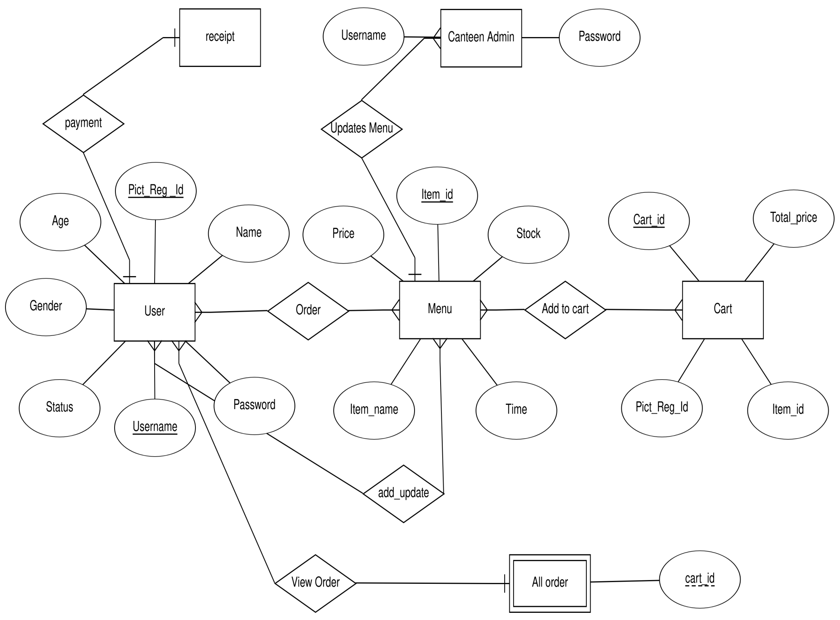

**Schema (Description of MySQL Tables) :**

**Customer Table:**

CREATE TABLE `customer` (

`c_id` int(11) NOT NULL,

`c_username` varchar(45) COLLATE utf8mb4_unicode_ci NOT NULL,

`c_pwd` varchar(45) COLLATE utf8mb4_unicode_ci NOT NULL,

`c_firstname` varchar(45) COLLATE utf8mb4_unicode_ci NOT NULL,

`c_lastname` varchar(45) COLLATE utf8mb4_unicode_ci NOT NULL,

`c_email` varchar(100) COLLATE utf8mb4_unicode_ci NOT NULL,

`c_gender` varchar(1) COLLATE utf8mb4_unicode_ci NOT NULL COMMENT 'M for Male, F for Female',

`c_type` varchar(3) COLLATE utf8mb4_unicode_ci NOT NULL COMMENT 'Type of customer in this canteen (STD for student, INS for instructor, STF for staff, GUE for guest, ADM for admin, OTH for other)'

) ENGINE=InnoDB DEFAULT CHARSET=utf8mb4 COLLATE=utf8mb4_unicode_ci;

**Food Table:**

CREATE TABLE `food` (

`f_id` int(11) NOT NULL,

`s_id` int(11) NOT NULL,

`f_name` varchar(100) COLLATE utf8mb4_unicode_ci NOT NULL,

`f_price` decimal(6,2) NOT NULL,

`f_todayavail` tinyint(4) NOT NULL DEFAULT 1 COMMENT 'Food is available to order or not',

`f_preorderavail` tinyint(4) NOT NULL DEFAULT 1,

`f_pic` text COLLATE utf8mb4_unicode_ci DEFAULT NULL

) ENGINE=InnoDB DEFAULT CHARSET=utf8mb4 COLLATE=utf8mb4_unicode_ci;

**Order_details Table:**

CREATE TABLE `order_detail` (

`ord_id` int(11) NOT NULL,

`orh_id` int(11) NOT NULL,

`f_id` int(11) NOT NULL,

`ord_amount` int(11) NOT NULL,

`ord_buyprice` decimal(6,2) NOT NULL COMMENT 'To keep the snapshot of selected menu cost at the time of the purchase.',

`ord_note` text COLLATE utf8mb4_unicode_ci DEFAULT NULL

) ENGINE=InnoDB DEFAULT CHARSET=utf8mb4 COLLATE=utf8mb4_unicode_ci;

**Order_header Table:**

CREATE TABLE `order_header` (

`orh_id` int(11) NOT NULL,

`orh_refcode` varchar(15) COLLATE utf8mb4_unicode_ci DEFAULT NULL,

`c_id` int(11) NOT NULL,

`s_id` int(11) NOT NULL,

`orh_ordertime` timestamp NOT NULL DEFAULT current_timestamp(),

`orh_pickuptime` datetime NOT NULL,

`orh_orderstatus` varchar(10) COLLATE utf8mb4_unicode_ci NOT NULL,

`orh_finishedtime` datetime DEFAULT NULL

) ENGINE=InnoDB DEFAULT CHARSET=utf8mb4 COLLATE=utf8mb4_unicode_ci;

**Shop Table:**

CREATE TABLE `shop` (

`s_id` int(11) NOT NULL,

`s_username` varchar(45) COLLATE utf8mb4_unicode_ci NOT NULL,

`s_pwd` varchar(45) COLLATE utf8mb4_unicode_ci NOT NULL,

`s_name` varchar(100) COLLATE utf8mb4_unicode_ci NOT NULL,

`s_location` varchar(100) COLLATE utf8mb4_unicode_ci NOT NULL,

`s_openhour` time NOT NULL,

`s_closehour` time NOT NULL,

`s_status` tinyint(4) NOT NULL DEFAULT 1 COMMENT 'Shop ready for taking an order or not (True for open, False for close)',

`s_preorderStatus` tinyint(4) NOT NULL DEFAULT 1 COMMENT 'Shop is ready for tomorrow pre-order or not',

`s_email` varchar(100) COLLATE utf8mb4_unicode_ci NOT NULL,

`s_phoneno` varchar(45) COLLATE utf8mb4_unicode_ci NOT NULL,

`s_pic` text COLLATE utf8mb4_unicode_ci DEFAULT NULL

) ENGINE=InnoDB DEFAULT CHARSET=utf8mb4 COLLATE=utf8mb4_unicode_ci;

**Test Cases:**

**Query 1:**

Admin Logs in.

**Expected Output:**

Admin Logged-in successfully and can do the required changed.

**Actual Output:**

Admin Logged-in successfully and can do the required changed

**Result:**

PASS

**Query 2:**

Customer Logs in.

**Expected Output:**

Customer can View the Menu and the Availability.

**Actual Output:**

Customer can View the Menu and the Availability.

**Result:**

PASS

**Query 3:**

Customer adds a item to cart and checkouts.

**Expected Output:**

1. Order Placed Successfully.
2. Item Not Available.

**Actual Output:**

1.Order Placed Successfully.

2. Item Not Available.

**Result:**

PASS

**Output Screenshots:**

**Index Page:**

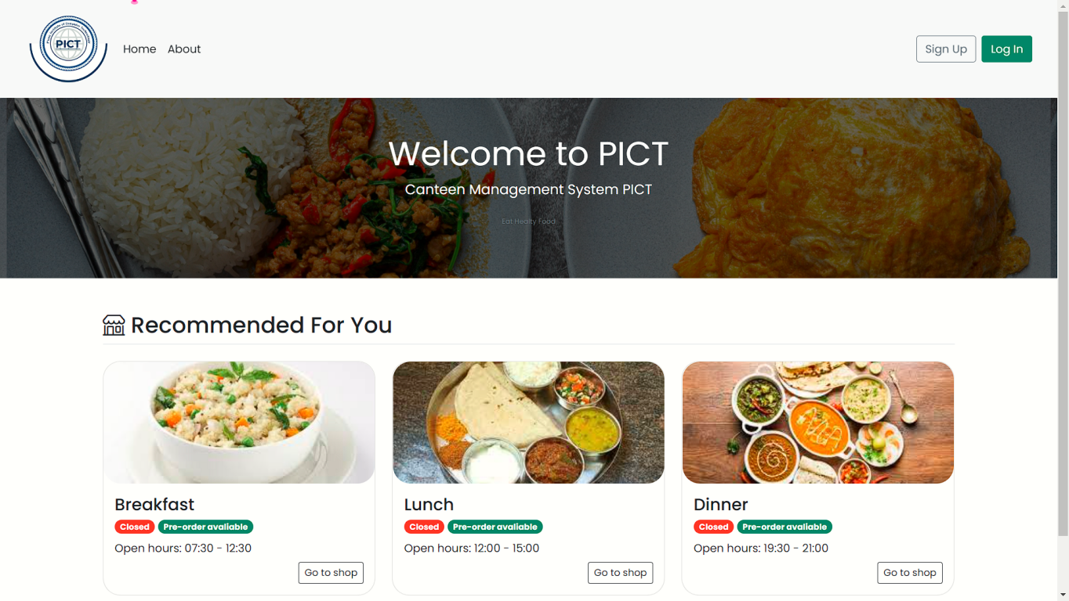

**LOGIN:**

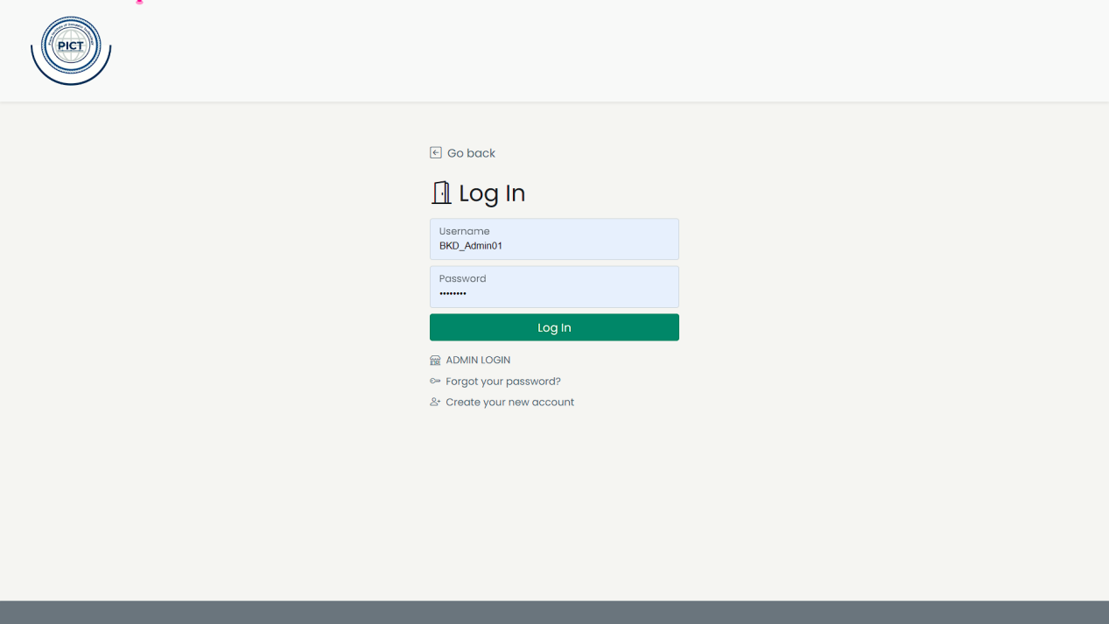

**Admin Login:**  
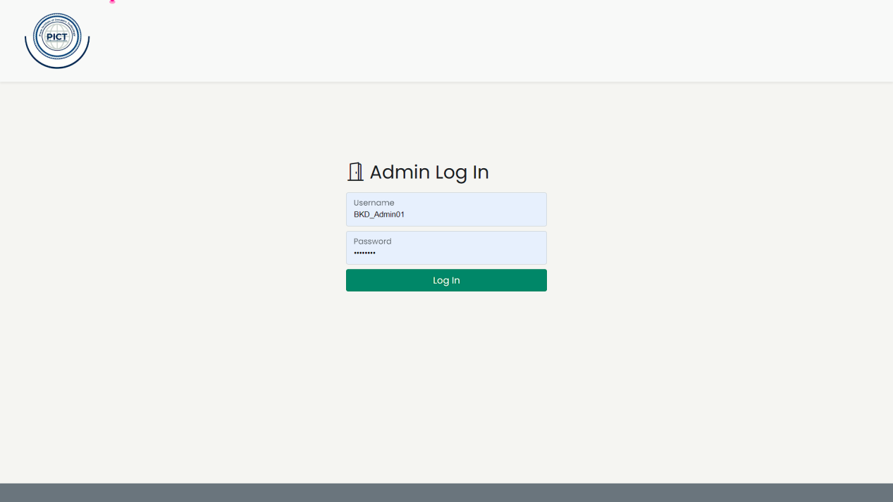

**Admin Dashboard:**

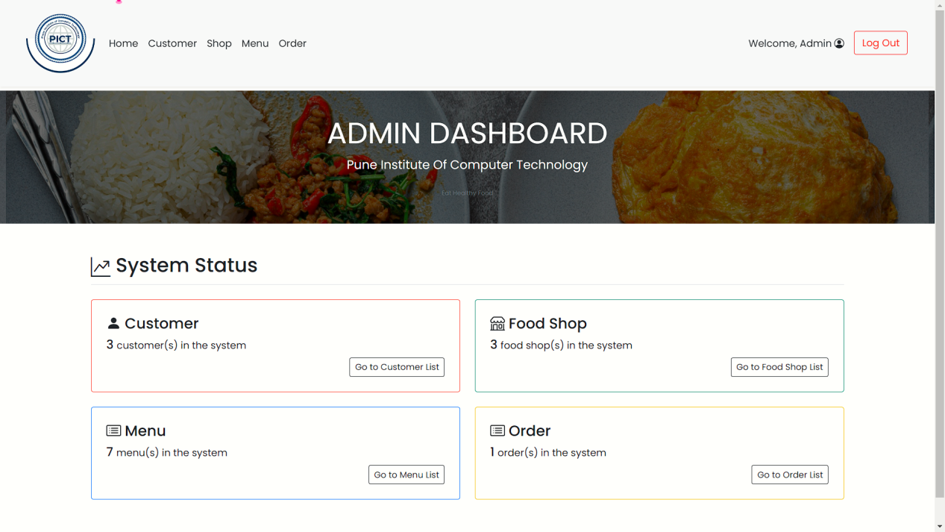

**Admin Edit Options:**

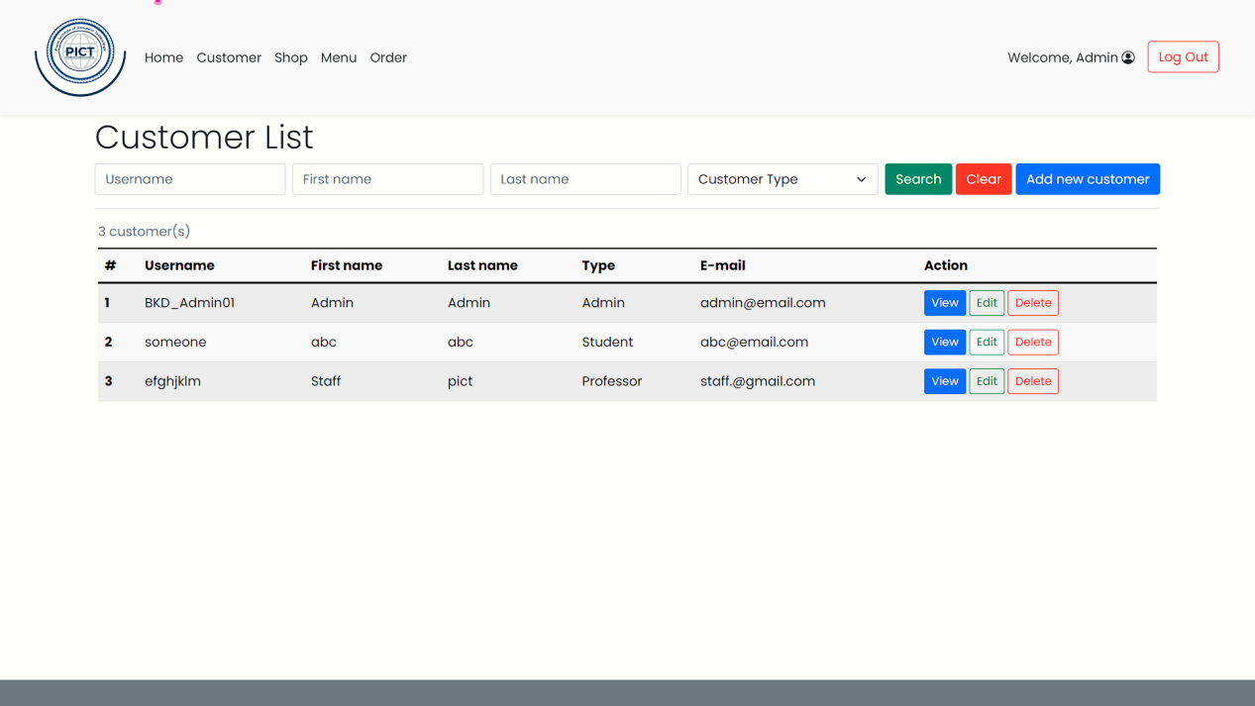

**Add New Customer by Admin:**

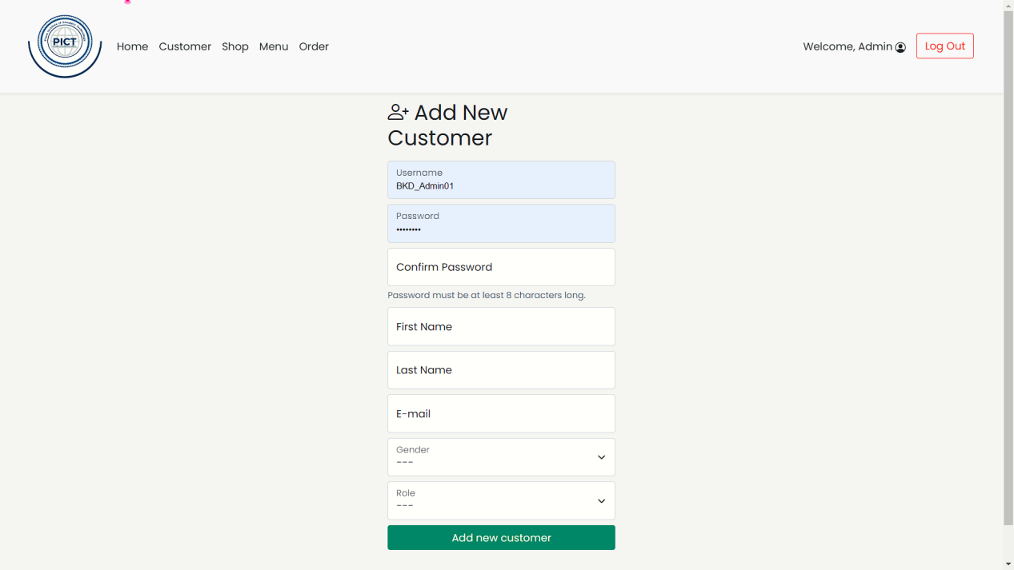

Shop List:

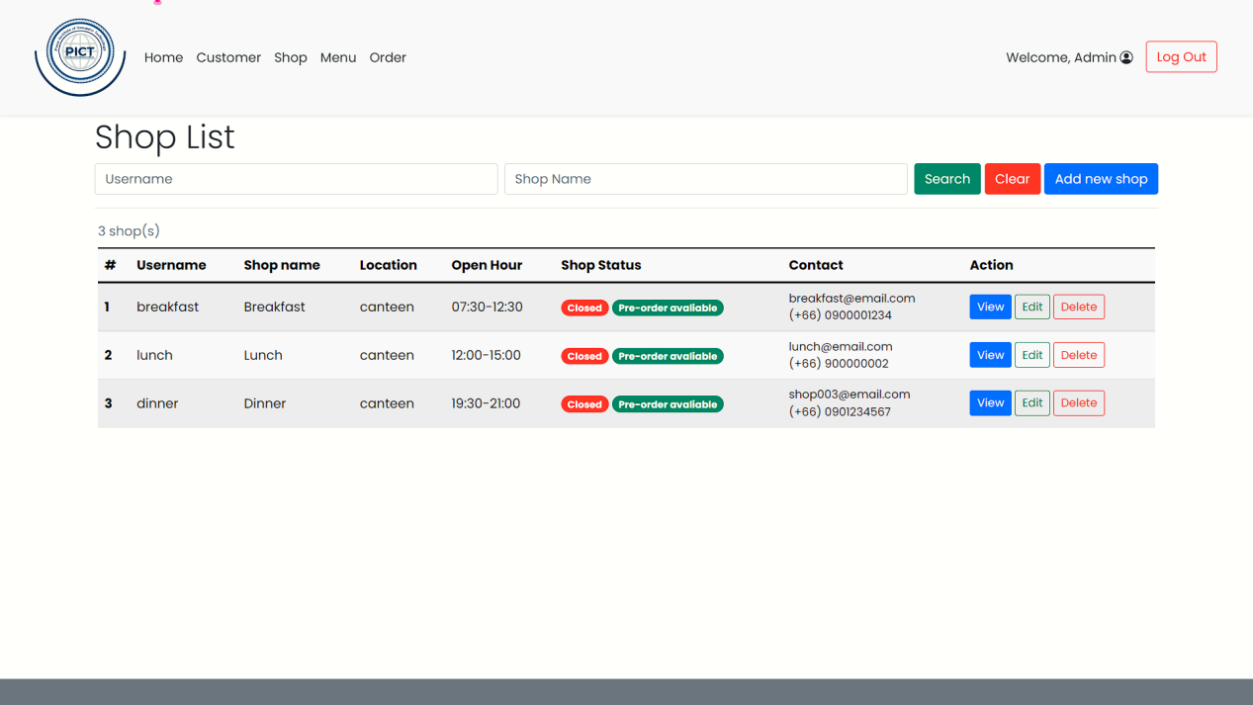

Add New Shop:

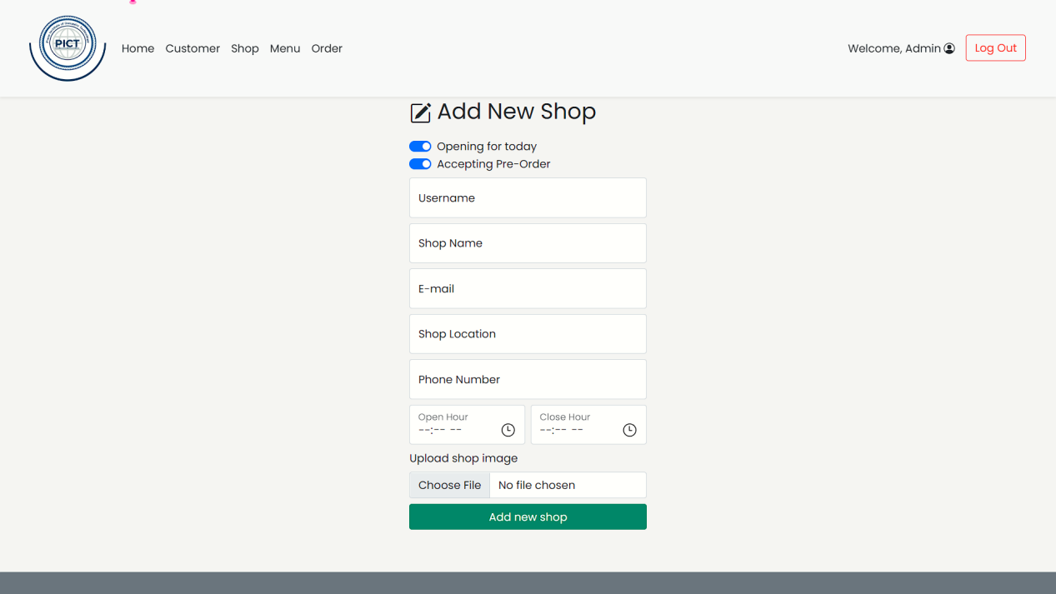

Menu List:

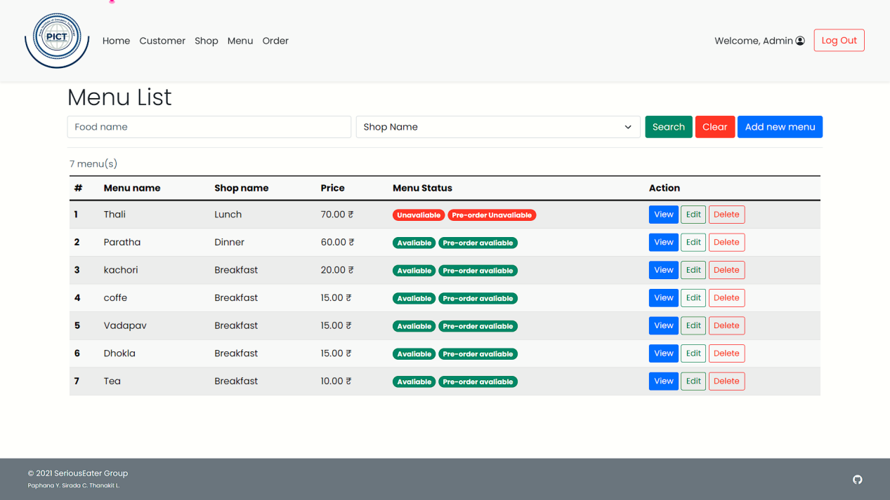

Add New Menu:

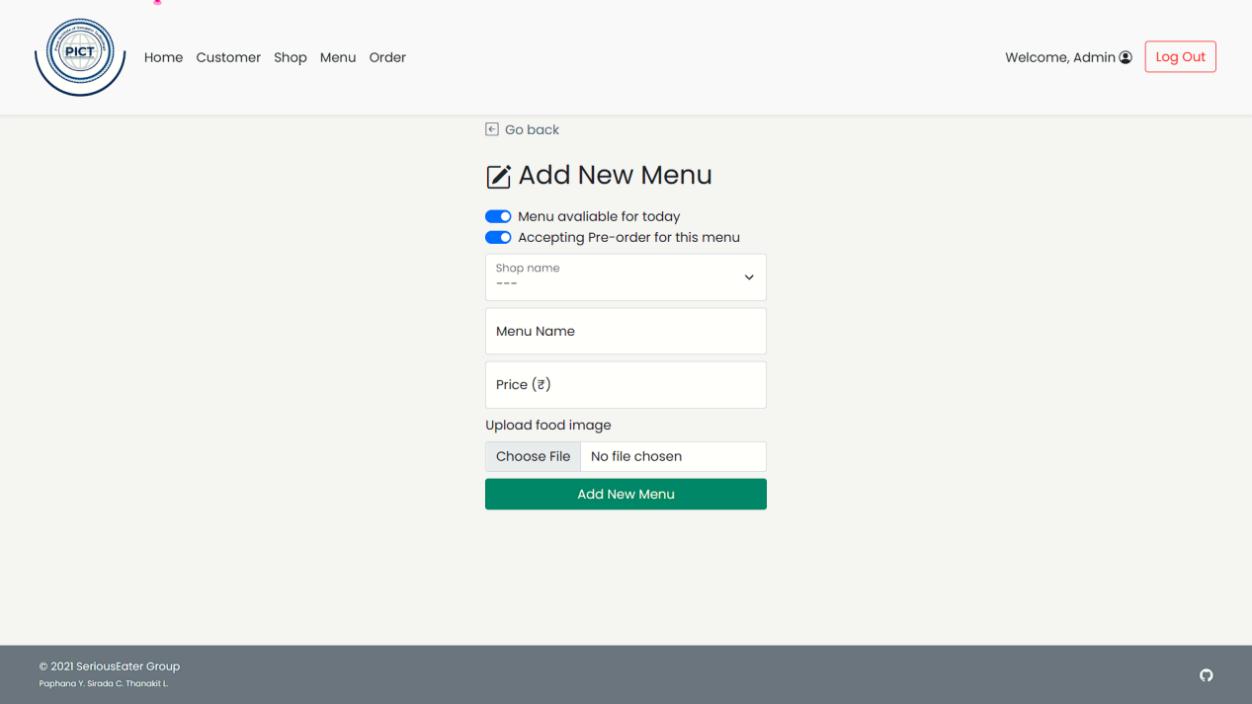

After Login Home Page:

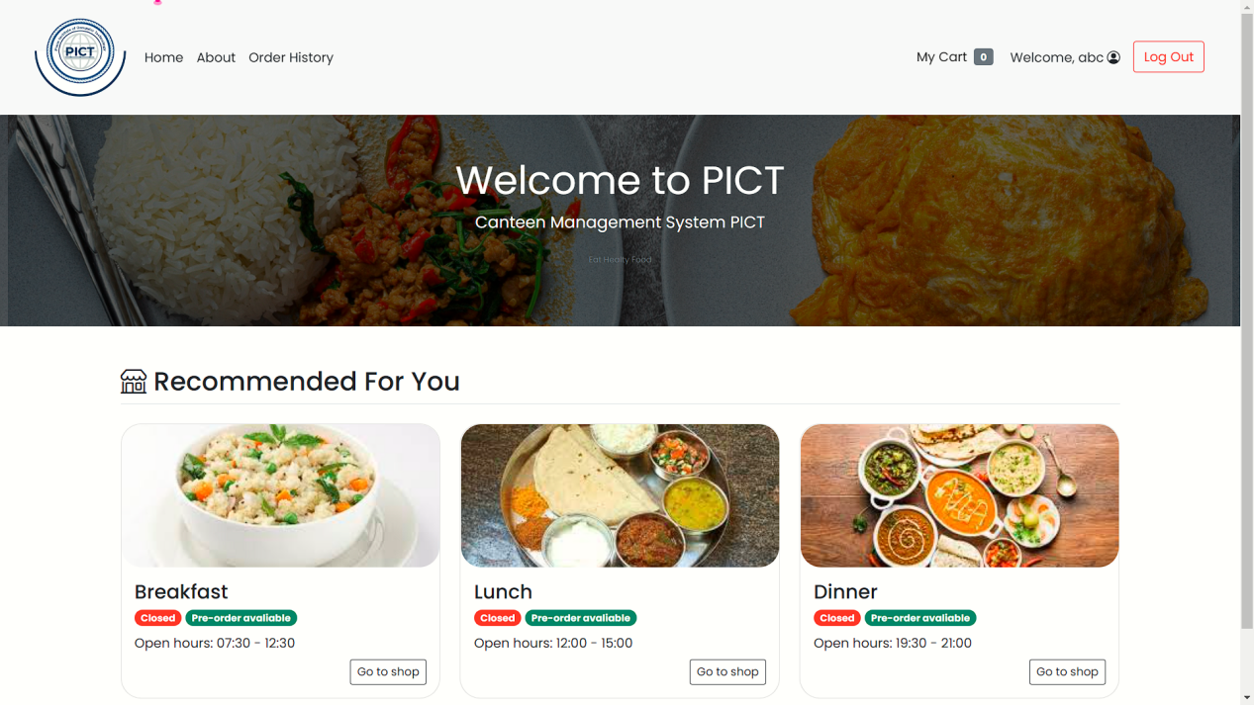

Breakfast Menu:

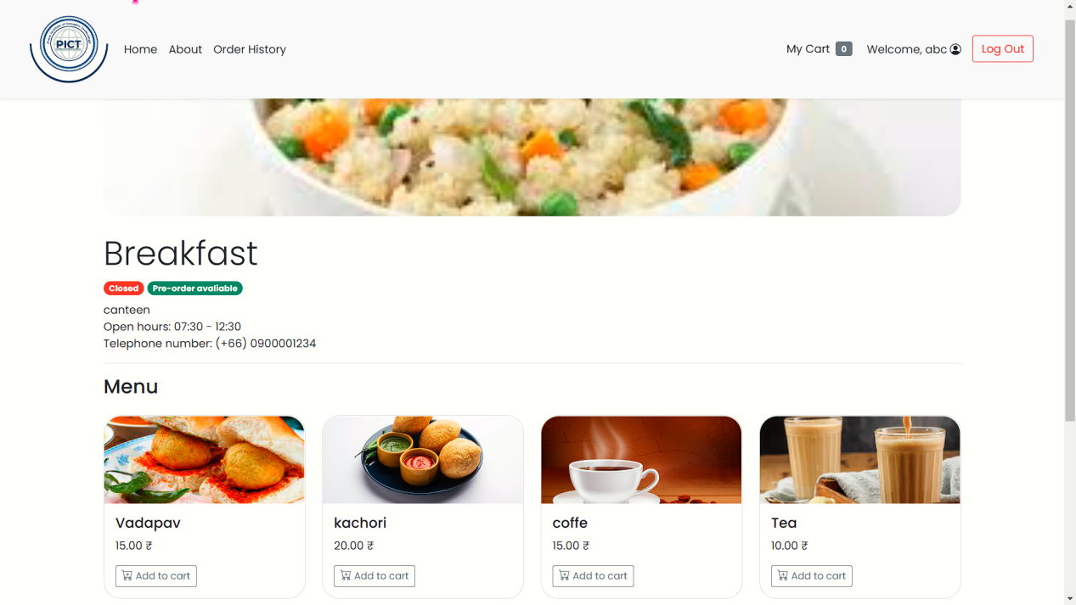

Adding Vadapav to Cart:

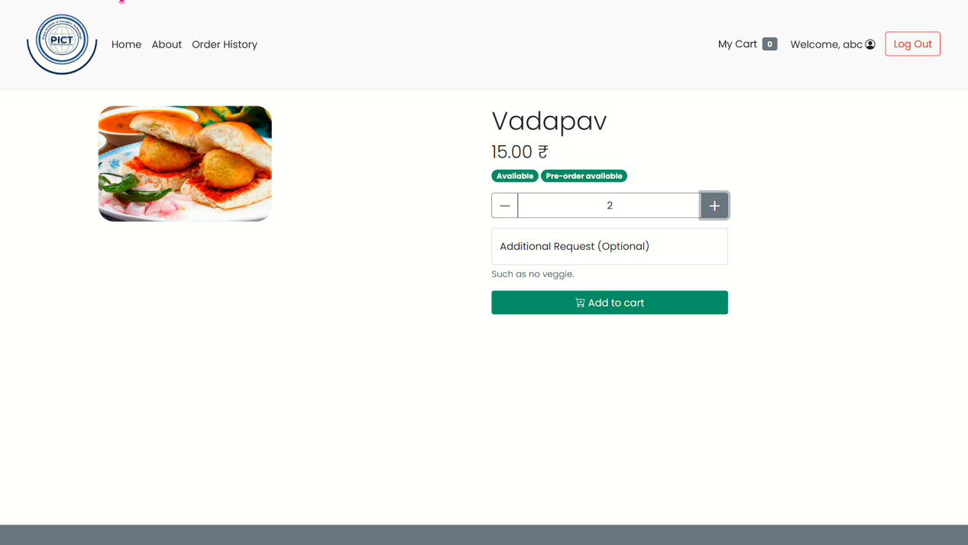

View of My Cart:

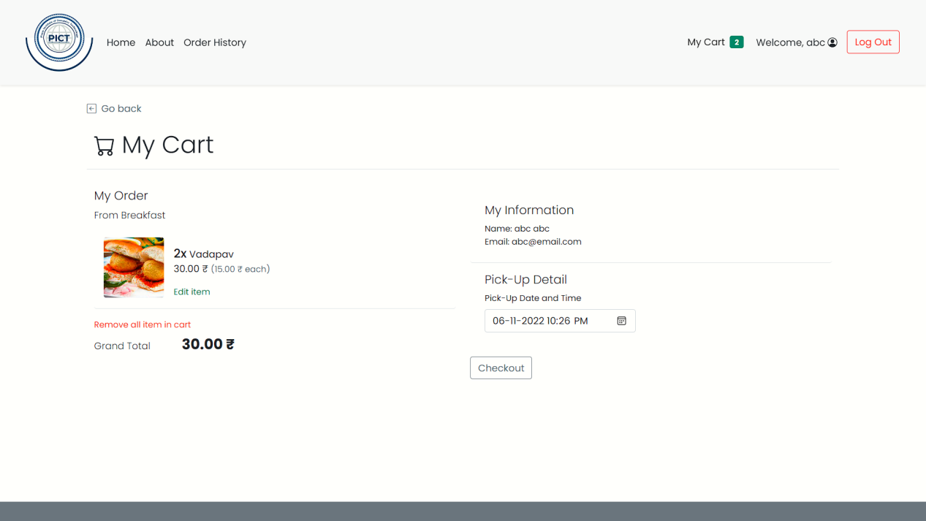

Order Being Placed Successfully:

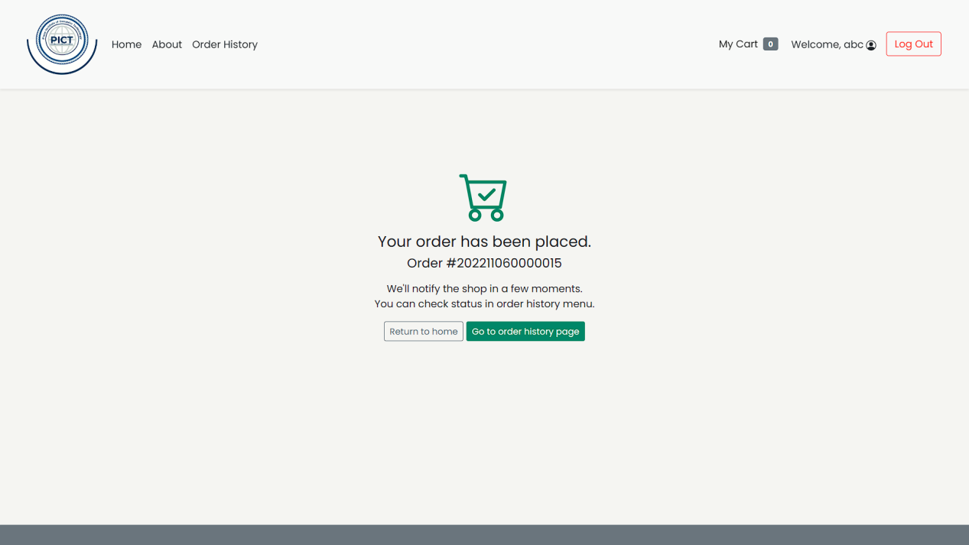

**CONCLUSION:**

Since we are entering details of the Customer electronically in the “ Canteen Management System ”, data will be secured. Using this application we can retrieve the orders with a single click. Thus processing information will be faster. It guarantees accurate maintenance of User Information. It easily reduces the crowding and paper manual task and thus reduces the human effort and increases accuracy speed.